Project Plan for “School Wood”

Outline:
Plant a new woodland with rides and glades on a 2ha area of pasture at the foot of Levin Down which is close to Singleton Primary School and is owned by The Goodwood Estate. The woodland will be for the use of the school for outdoor learning including Forest School. In addition to this the woodland will increase biodiversity on The Goodwood Estate by providing new scrub and woodland habitat to act as a stepping stone between other key woodland habitats on the Estate and neighbouring land. The project will also help to reduce surface water entering the River Lavant in an area which is prone to flooding.
These outcomes reflect the purposes of the South Downs National Park Authority to protect and enhance the landscape and provide opportunities for learning and enjoyment. This project will support the delivery of the South Downs National Park’s Partnership Management Plan.
Location:
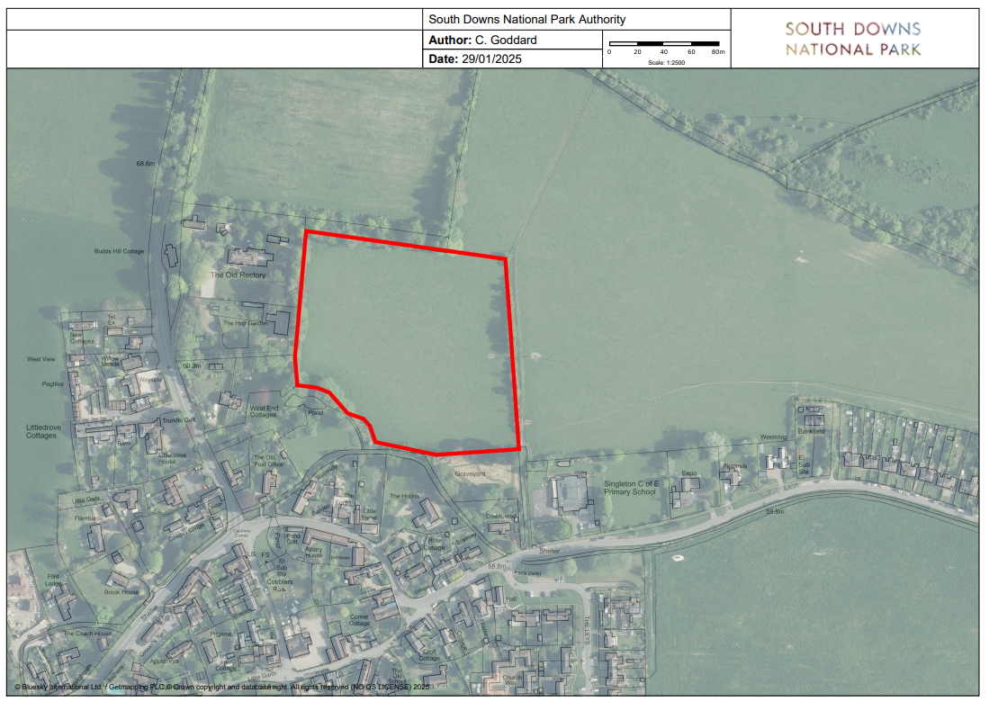

Woodland composition:
The project aims to plant nearly 3000 trees on the site. A diverse mix of tree species will support a greater range of wildlife and offer the best resilience to pests, diseases and climate change. A mixture of high canopy and shrub layer trees will be planted. More trees will be planted of species which are known to grow well on similar soils.
There will be blocks where a single species or species mix is dominant to support with future woodland management and to create distinctive areas within the woodland. Some areas will be planted more densely while others will have clumps of trees planted in open space allowing room for natural regeneration. Trees will be planted with approximate spacing, not in straight rows.
Whips:

Species | Number
Pedunculate Oak | 200
Beech | 200
Field maple | 150
Hazel | 200
Hawthorn | 150
Whitebeam | 100
Yew | 50
Hornbeam | 75
Small-leaved lime | 75
Large leaved lime | 75
Disease resistant elm | 75
Cherry | 100
Rowan | 100
Aspen | 35
Scots pine | 50
Holly | 100
Wild service | 75
Wych elm | 40
Spindle | 75
Crab apple | 50
Goat willow | 200
Walnut | 40
Sweet chestnut | 150
Blackthorn | 75
Guelder rose | 40
Wayfaring tree | 50
Dogwood | 40
Juniper | 50
Silver birch | 75
Alder buckthorn | 40
Dogrose | 50
Common buckthorn | 50
Elder | 75
33 species | 2910 trees

The project will also plant a standard tree for each of the three classes which make up Singleton School: Willow, Beech, Oak.
South of the overhead power lines woodland trees will not be planted. Instead this area will be seeded with wildflowers and planted as an orchard. Local fruit varieties will be chosen.
Standard trees will be planted with mulch.

Standards:
Species | Number
Willow | 1
Beech | 1
Oak | 1
Sussex variety Apples | 5 | e.g. Egremont Russet, Golden Pippin, Green Custard, Knobby Russet
Sussex variety Pear | 5 | e.g. Invincible Delwinor,
Plum | 3
Quince | 1
Purple filibut | 1
Walnut | 1
9 + species | 19

Some additional planting of climbing and scrub species may be undertaken including honeysuckle, bramble, white briony.

Fencing
The site will be deer fenced which will allow natural scrub and tree regeneration from surrounding hedges and gardens to supplement the woodland planting, as well as avoid the cost and environmental impact of thousands of tree tubes.
The site will require 550m of 182cm tall deer fencing and a metal access gate for vehicles. Funding for this has been approved through the South Downs Capital Works fund.

Public access
The project area will be easily visible from the right of way adjacent and is currently informally used by the public for dog walking. The new gate will have a padlock that the school will have access to at any time. This will exclude dogs and the public from the site which will protect wildlife from disturbance by dogs and protect the children from coming into contact with members of the public, dogs and dog mess whilst using the woodland.
The school children could support with signage for the new fencing to explain the project and the reasons for the new fence.

Survey and monitoring:
The site will undergo some baseline surveys and be monitored by the school with support from the SDNPA Ranger team as the woodland develops.
The dominant species on the site is perennial ryegrass with some chickory mixed in.
Surveys of the site will begin this summer and may include:
- Static bird song recorder
- Bat echolocation recorder
- Moth trap?
- Soil biology?
- Plant species list
- Insect counts

Planting:
Planting will take place in the autumn with various support for tree planting will come from:
- School children
- SDNPA Ranger Team and wider organisation
- Goodwood Estate Staff
- Community groups e.g. Aldingbourne Trust
- SDNPA volunteers
- School families
- Other local schools?

Aftercare:
Standard trees will be mulched but may need watering during the growing season if conditions are dry. The school might be able to factor this into their forest school sessions?
SDNPA rangers could support the management of the woodland, possibly by giving ownership to the school pupils for a manageable amount of tree care and/or forming a parent/carer volunteer team.
Ride management may be needed from time to time. This could also be supported by SDNPA Rangers and volunteers but it may be possible for the rides to be added into an existing programme of woodland management by the Goodwood Estate.

Hedgelaying:
The Goodwood Farm Team may be interested in laying the hedge along the footpath and additional planting of standard trees beyond where the existing hedge ends. These are projects which could be incorporated into the School Wood project and the SDNPA could support if desired.

Orchard:
It has been decided that the orchard planting may happen in the following year, to give the school more of an opportunity to be involved in choosing apple varieties etc. and to spread the work across multiple years.

